**Name - Gaurang A Raorane Roll No - 49**

**Class - D15A Batch - C**

**EXPERIMENT 10**

**Aim:-** Use the NESSUS Kali Linux tool to scan the network for vulnerabilities.

**Theory:-**

In the realm of cybersecurity, identifying vulnerabilities within networked systems is paramount to maintaining a secure infrastructure. Vulnerability assessment tools like Nessus are instrumental in automating the process of identifying potential security flaws. This lab aims to impart practical skills in conducting network vulnerability assessments using Nessus within a Kali Linux environment.

Nessus is a widely used and powerful network vulnerability scanner and security assessment tool. It is designed to identify and assess vulnerabilities and security issues in computer systems, networks, and applications. Nessus is used by security professionals, system administrators, and organizations to enhance their overall cybersecurity posture.

* **Vulnerability Assessment:** The process of identifying, quantifying, and prioritizing security vulnerabilities within a network or system.
* **Nessus:** A widely-used vulnerability assessment tool known for its ability to identify and assess security weaknesses in networked environments.
* **Plugins:** Nessus uses a vast collection of plugins to perform various vulnerability checks. Each plugin focuses on specific vulnerabilities or security misconfigurations.
* **Scanning Policies:** Nessus allows users to define scanning policies that determine which plugins to use, the scope of the scan, and scan frequency.

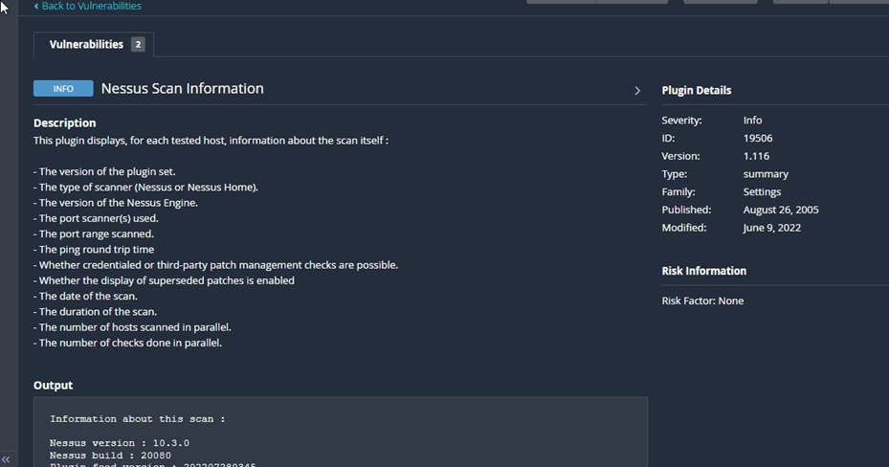

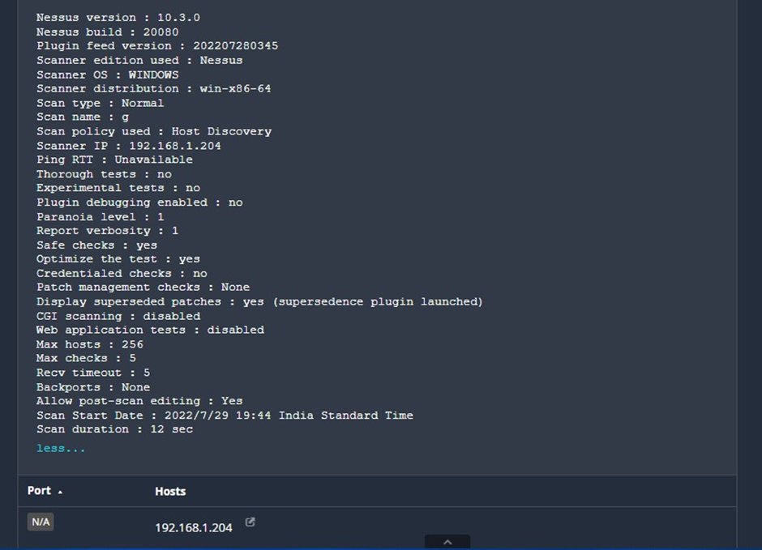

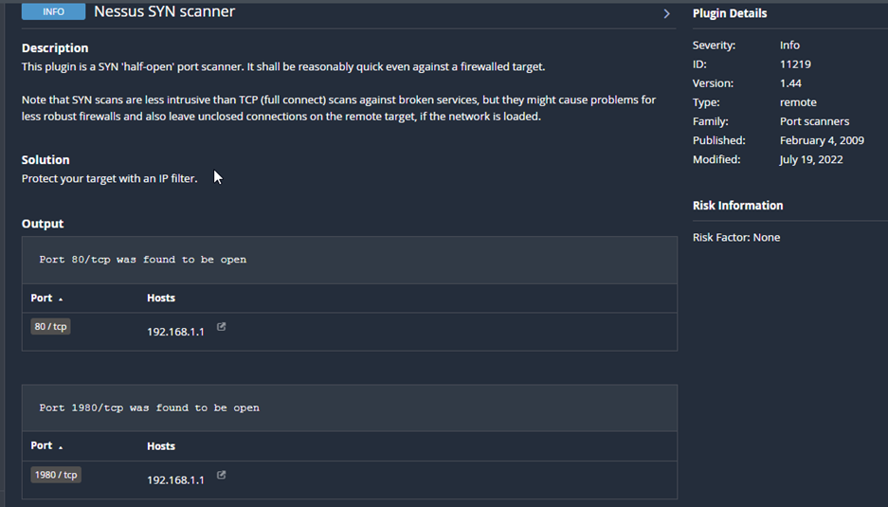

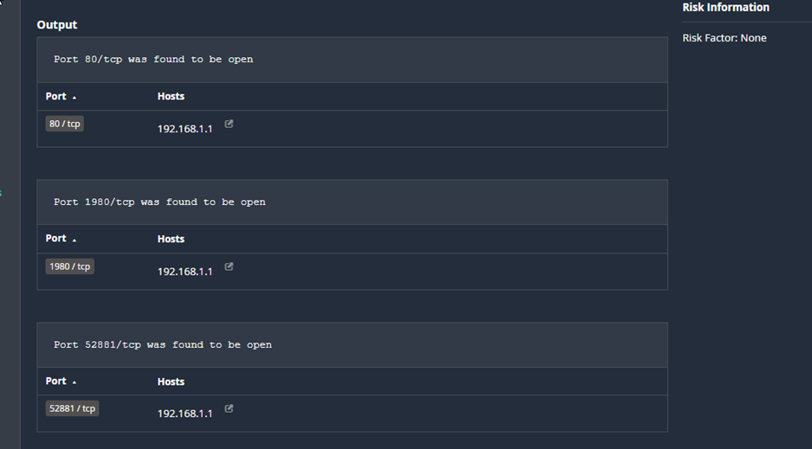

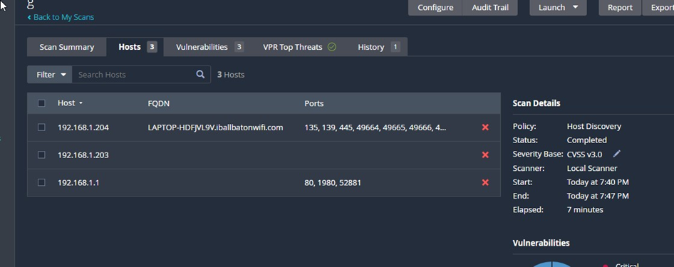

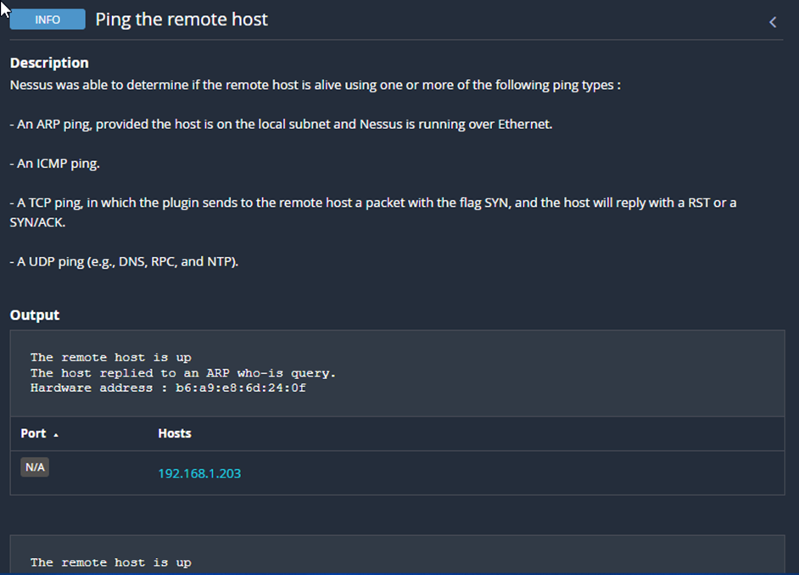

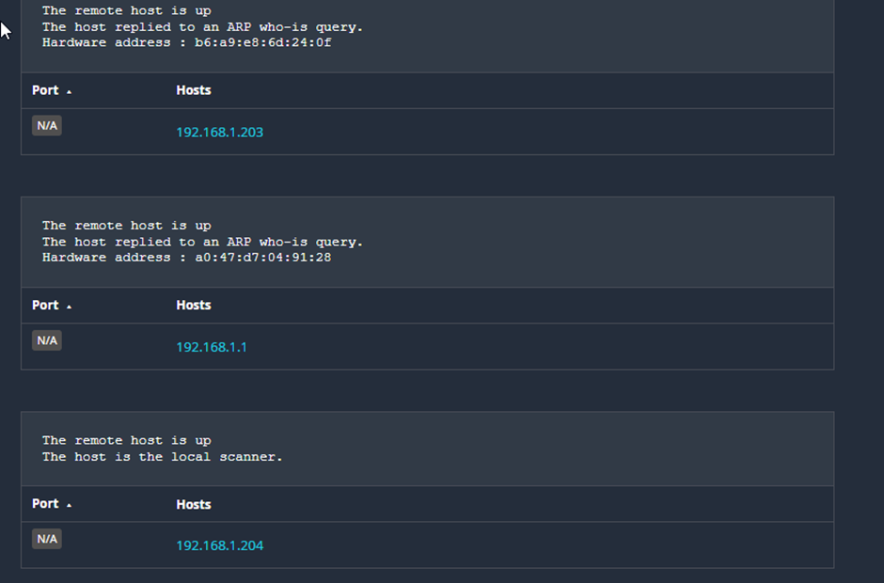

**Conclusion:-** Used the Nessus Kali linux tool to scan the network for vulnerabilities.